Yom HaZikaron 2024

Central MA Community Ceremony

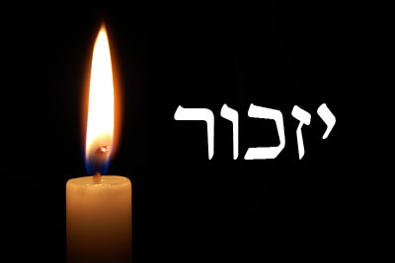

**Opening Remarks**

**Yizkor**

**We remember those who are no longer with us with the words of Yizkor, please rise in body or spirit.**

|  |  |
| --- | --- |
| May the people of Israel remember the brave and faithful sons and daughters, soldiers of the Israeli defense forces, Israel's earliest fighters, all members of the defense community, and members of the Israeli police force that gave their lives for the existence of the state of Israel. May we always remember all those who were murdered, both in and out of the state of Israel by terrorists and terror organizations. | יִזְכֹּר עַם יִשְׂרָאֵל אֶת בָּנָיו וּבְנוֹתָיו, הַנֶּאֱמָנִים וְהָאַמִּיצִים,  חַיָּלֵי צְבָא הַהֲגָנָה לְיִשְׂרָאֵל,  וְכָל לוֹחֲמֵי הַמַּחְתָּרוֹת וַחֲטִיבוֹת הַלּוֹחֲמִים בְּמַעַרְכוֹת הָעָם,  וְאַנְשֵׁי קְהִלּוֹת הַמּוֹדִיעִין, הַבִּטָּחוֹן, הַמִּשְׁטָרָה וְשֵׁרוּת בָּתֵּי הַסֹּהַר,  אֲשֶׁר חֵרְפוּ נַפְשָׁם בַּמִּלְחָמָה עַל תְּקוּמַת יִשְׂרָאֵל,  וְכָל מִי שֶׁנִּרְצְחוּ בָּאָרֶץ וּמִחוּצָה לָהּ בִּידֵי מְרַצְּחִים מֵאִרְגּוּנֵי הַטֵּרוֹר. |

**Lighting Memorial Candle**

We light this candle of commemoration in memory of all the fallen soldiers, and the victims of terrorism.

**The Story of Eyal Twito z"l**

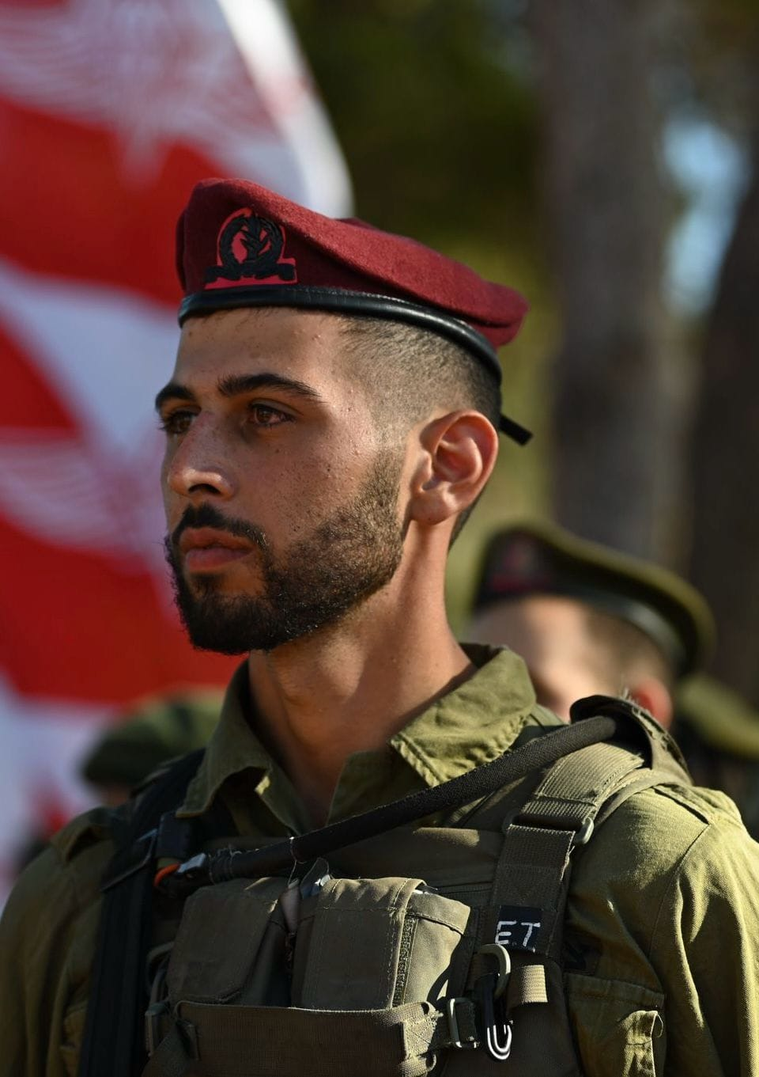

**Mourner's Kaddish**

|  |  |
| --- | --- |
| Yitgadal v’yitkadash sh’mei raba b’alma di-v’ra  chirutei, v’yamlich malchutei b’chayeichon  uvyomeichon uvchayei d’chol beit yisrael, ba’agala  uvizman kariv, v’im’ru: “amen.”  Y’hei sh’mei raba m’varach l’alam ul’almei almaya.  Yitbarach v’yishtabach, v’yitpa’ar v’yitromam  v’yitnaseh, v’yithadar v’yit’aleh v’yit’halal sh’mei  d’kud’sha, b’rich hu,  l’eila min-kol-birchata v’shirata, tushb’chata  v’nechemata da’amiran b’alma, v’im’ru: “amen.”  Y’hei shlama raba min-sh’maya v’chayim aleinu  v’al-kol-yisrael, v’im’ru: “amen.”  Oseh shalom bimromav, hu ya’aseh shalom aleinu  v’al kol-yisrael, v’imru: “amen.” | אבל: יִתְגַּדַּל וְיִתְקַדַּשׁ שְׁמֵהּ רַבָּא. [קהל: אמן]  בְּעָלְמָא דִּי בְרָא כִרְעוּתֵהּ וְיַמְלִיךְ מַלְכוּתֵהּ בְּחַיֵּיכון וּבְיומֵיכון וּבְחַיֵּי דְכָל בֵּית יִשרָאֵל בַּעֲגָלָא וּבִזְמַן קָרִיב, וְאִמְרוּ אָמֵן: [קהל: אמן]  קהל ואבל: יְהֵא שְׁמֵהּ רַבָּא מְבָרַךְ לְעָלַם וּלְעָלְמֵי עָלְמַיָּא:  אבל: יִתְבָּרַךְ וְיִשְׁתַּבַּח וְיִתְפָּאַר וְיִתְרומַם וְיִתְנַשּא וְיִתְהַדָּר וְיִתְעַלֶּה וְיִתְהַלָּל שְׁמֵהּ דְּקֻדְשָׁא. בְּרִיךְ הוּא. [קהל: בריך הוא:]  לְעֵלָּא מִן כָּל בִּרְכָתָא בעשי”ת: לְעֵלָּא לְעֵלָּא מִכָּל וְשִׁירָתָא תֻּשְׁבְּחָתָא וְנֶחֱמָתָא דַּאֲמִירָן בְּעָלְמָא. וְאִמְרוּ אָמֵן: [קהל: אמן]  יְהֵא שְׁלָמָא רַבָּא מִן שְׁמַיָּא וְחַיִּים עָלֵינוּ וְעַל כָּל יִשרָאֵל. וְאִמְרוּ אָמֵן: [קהל:אמן]  עושה שָׁלום בעשי”ת: הַשָּׁלום בִּמְרומָיו הוּא יַעֲשה שָׁלום עָלֵינוּ וְעַל כָּל יִשרָאֵל וְאִמְרוּ אָמֵן: [קהל: אמן] |

**When the Sun Will Rise Again  
(Written by: Nunu)**

Come, let’s count the roses one by one,

The endless roses on the road, growing in the dark.

Soon, you will come to see how beautiful they are,

When the sun will rise again, when the sun will rise again.

Just hold my hand when you’re able,

Just hold my hand when you can,

Just hold my hand and we’ll get there,

When the sun will rise again, when the sun will rise again.

**Prayer for Israel**

|  |  |
| --- | --- |
| Our Father who is in heaven, Protector and Redeemer of Israel, bless the State of Israel, the dawn of our deliverance. Shield it beneath the wings of Your love; spread over it Your canopy of peace; send Your light and Your truth to its leaders, officers, and counselors, and direct them with Your good counsel.  Strengthen the defenders of our Holy Land; grant them, our God, salvation and crown them with victory. Establish peace in the land, and everlasting joy for its inhabitants. | אָבִינוּ שֶׁבַּשָּׁמַיִם,  צוּר יִשְׂרָאֵל וְגוֹאֲלוֹ,  בָּרֵךְ אֶת מְדִינַת יִשְׂרָאֵל,  רֵאשִׁית צְמִיחַת גְּאֻלָּתֵנוּ.  הָגֵן עָלֶיהָ בְּאֶבְרַת חַסְדֶּךָ,  וּפְרֹשׂ עָלֶיהָ סֻכַּת שְׁלוֹמֶךָ,  וּשְׁלַח אוֹרְךָ וַאֲמִתְּךָ לְרָאשֶׁיהָ, שָׂרֶיהָ וְיוֹעֲצֶיהָ,  וְתַקְּנֵם בְּעֵצָה טוֹבָה מִלְּפָנֶיךָ.  חַזֵּק אֶת יְדֵי מְגִנֵּי אֶרֶץ קׇדְשֵׁנוּ,  וְהַנְחִילֵם אֱלֹהֵינוּ יְשׁוּעָה  וַעֲטֶרֶת נִצָּחוֹן תְּעַטְּרֵם,  וְנָתַתָּ שָׁלוֹם בָּאָרֶץ,  וְשִׂמְחַת עוֹלָם לְיוֹשְׁבֶיהָ. |

**Prayer for the Soldiers**

|  |  |
| --- | --- |
| He Who blessed our forefathers Abraham, Isaac and Jacob - may He bless the fighters of the Israel Defense Force, who stand guard over our land and the cities of our God from the border of the Lebanon to the desert of Egypt, and from the Great Sea unto the approach of the Aravah, on the land, in the air, and on the sea. | מִי שֶׁבֵּרַךְ אֲבוֹתֵינוּ  אַבְרָהָם יִצְחָק וְיַעֲקֹב,  הוּא יְבָרֵךְ אֶת חַיָּלֵי צְבָא הַהֲגַנָּה לְיִשְׂרָאֵל  [וְאַנְשֵׁי כֹּחוֹת הַבִּטָּחוֹן],  הָעוֹמְדִים עַל מִשְׁמַר אַרְצֵנוּ וְעָרֵי אֱלֹהֵינוּ,  מִגְּבוּל הַלְּבָנוֹן וְעַד מִדְבַּר מִצְרַיִם,  וּמִן הַיָּם הַגָּדוֹל עַד לְבוֹא הָעֲרָבָה  [וּבְכָל מָקוֹם שֶׁהֵם],  בַּיַּבָּשָׁה בָּאֲוִיר וּבַיָּם. |

**Prayer for the Hostages**

|  |  |
| --- | --- |
| Our brothers, the entire house of Israel,  who are in distress and captivity,  who stand between the sea and the dry land,  may G-d have mercy upon them,  and bring them from distress to relief,  from darkness to light,  and from subjugation to redemption,  now, swiftly, and in the near future.  And let us say, Amen. | אַחֵינוּ כָּל בֵּית יִשְׂרָאֵל  הַנְּתוּנִים בַּצָּרָה וּבַשִּׁבְיָה  הָעוֹמְדִים בֵּין בַּיָּם וּבֵין בַּיַּבָּשָׁה  הַמָּקוֹם יְרַחֵם עֲלֵיהֶם  וְיוֹצִיאֵם מִצָּרָה לִרְוָחָה  וּמֵאֲפֵלָה לְאוֹרָה  וּמִשִּׁעְבּוּד לִגְאֻלָּה  הָשָׁתָא בַּעֲגָלָא וּבִזְמַן קָרִיב  וְנֹאמַר אָמֵן |

**Am Yisrael Chai  
(CBS Choir)**

**Video Clip – Hurricane**

**Closing Remarks – From Grief to Hope**

**Here Comes the Sun  
(The Beatles)**

|  |  |
| --- | --- |
| Here comes the sun, doo-doo-doo-doo  Here comes the sun, and I say  It's alright  Little darlin', it's been a long, cold, lonely winter  Little darlin', it feels like years since it's been here  Here comes the sun, doo-doo-doo-doo  Here comes the sun, and I say  It's alright  Little darlin', the smile's returning to their faces  Little darlin', it seems like years since it's been here  Here comes the sun  Here comes the sun, and I say  It's alright | Sun, sun, sun, here it comes  Sun, sun, sun, here it comes  Sun, sun, sun, here it comes  Sun, sun, sun, here it comes  Sun, sun, sun, here it comes  Little darlin', I feel that ice is slowly melting  Little darlin', it seems like years since it's been clear  Here comes the sun, doo-doo-doo-doo  Here comes the sun, and I say  It's alright  Here comes the sun, doo-doo-doo-doo  Here comes the sun  It's alright  It's alright |

**HaTikvah**

|  |  |
| --- | --- |
| Kol ‘od balevav penimah  Nefesh Yehudi homiyah,  Ulfa’atey mizrach kadimah,  ‘Ayin leTziyon tzofiyah;  ‘Od lo avdah tikvatenu,  Hatikvah bat shnot ’alpayim,  Lihyot ‘am chofshi be’artzenu,  ’Eretz Tziyon v'Yerushalayim. | כֹּל עוֹד בַּלֵּבָב פְּנִימָה  נֶפֶשׁ יְהוּדִי הוֹמִיָּה,  וּלְפַאֲתֵי מִזְרָח קָדִימָה,  עַיִן לְצִיּוֹן צוֹפִיָּה;  עוֹד לֹא אָבְדָה תִּקְוָתֵנוּ,  הַתִּקְוָה בַּת שְׁנוֹת אַלְפַּיִם,  לִהְיוֹת עַם חָפְשִׁי בְּאַרְצֵנוּ,  אֶרֶץ צִיּוֹן וִירוּשָׁלַיִם. |