The Israeli Flag
Age: Adaptable to any age.
Time: 30 min with an option for 50 min.
Goals: Learning the history of the Israeli flag, understanding the importance of symbols.
Opening:
Show the Israeli flag. Ask the students:
- What do they notice about the flag?
- What do the different symbols represent?
- Why do they think this version of the flag was chosen from countless others?
Optional to write their answers on the board so everyone can see (10 min).
Body:
Divide the class into smaller groups (no more than 4 in a group). Present them with their task; a new young Jewish state is rising, and it’s in need of a flag. Their goal is to make the best flag for this new country. Focuses for the flag:
- Think about the main values you'd like to represent.
- Think about Jewish symbols.
- Think about historical events that happened to our people.
(20 min).
Each group will present their newly drawn flag to the class (to spice things up tell the groups to think of a fun presentation of their flag). The class will vote on who's flag will represent their new country. (10-15 min).
Ending:
Ask the class what do they think of the flags presented?
Show them a few of the alternative options for the current day Israeli flag, encourage conversation. (10 min).
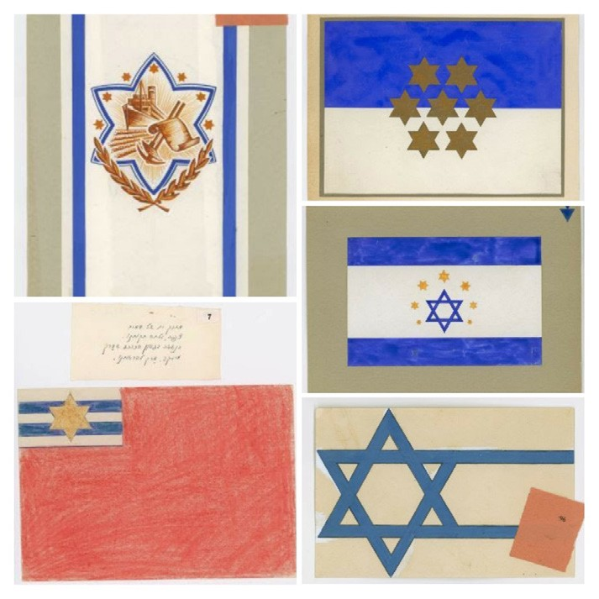
Alternative options that were suggested as the Israeli flag.

