**The Desert and Eilat**

**Ages:** Between 8-12 grade.

**Time:** 50 min.

**Body:**

* **First Envelope** – "Eilat, or as some may say, 'the capitol of the south', is the main attraction in the southern part of Israel. So many hotels in that city.  
  When Eilat was founded, in 1949, it was taken over. But the soldiers didn't have a flag to declare as their own, so they took a piece of white fabric and drew with ink on the flag.  
  Your mission is to find pieces of the flag which are hidden around temple! Good luck!" (10 min).
* **Second Envelope** – "One of the things Eilat is known for is its Coral Reef. A magnificent place.  
  You will need to form your own reef! How will you do it? Well that you'll find out very soon. Good luck!" (10 min).
* **Third Envelope** – "**David Ben Gurion** was the first prime minister ever of Israel! He lived mostly in a small Kibbutz called S'de Boker and was known for loving to do a head stand on the beach.  
  You will need to attempt a head stand! The team with the most time they did a head stand will win a point! Good luck!" (7 min).

**Ending**:

What did you like most about today's activity and all the lessons in general? (5 min).

What do you think needs improvement? (5 min).

Something new you learned about Israel in the past 5 lessons. (5 min).

Ask any question that comes to mind about us, about Israel, about whatever. (5 min).

Announcing the winners and handing out prizes. (5 min).

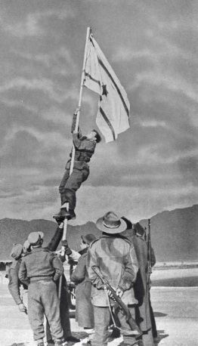

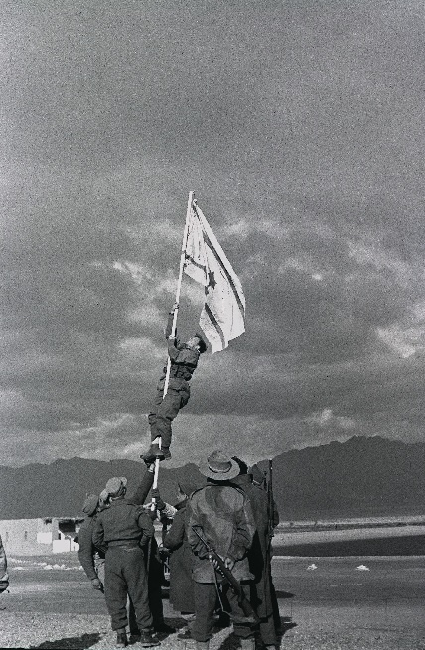Eilat, or as some may say, 'the capitol of the south', is the main attraction in the southern part of Israel. So many hotels in that city.  
When Eilat was founded, in 1949, it was taken over. But the soldiers didn't have a flag to declare as their own, so they took a piece of white fabric and drew with ink on the flag.  
Your mission is to find pieces of the flag which are hidden around temple! Good luck!

Eilat, or as some may say, 'the capitol of the south', is the main attraction in the southern part of Israel. So many hotels in that city.  
When Eilat was founded, in 1949, it was taken over. But the soldiers didn't have a flag to declare as their own, so they took a piece of white fabric and drew with ink on the flag.  
Your mission is to find pieces of the flag which are hidden around temple! Good luck!

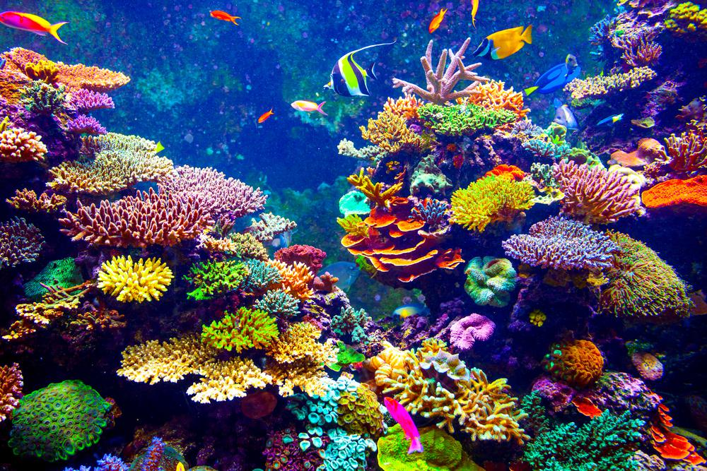Eilat, or as some may say, 'the capitol of the south', is the main attraction in the southern part of Israel. So many hotels in that city.

One of the things Eilat is known for is its Coral Reef. A magnificent place.  
You will need to form your own reef! How will you do it? Well that you'll find out very soon. Good luck!

Eilat, or as some may say, 'the capitol of the south', is the main attraction in the southern part of Israel. So many hotels in that city.

One of the things Eilat is known for is its Coral Reef. A magnificent place.  
You will need to form your own reef! How will you do it? Well that you'll find out very soon. Good luck!

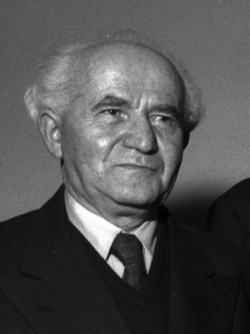**David Ben Gurion** was the first prime minister ever of Israel! He lived mostly in a small Kibbutz called S'de Boker and was known for loving to do a head stand on the beach.  
You will need to attempt a head stand! The team with the most time they did a head stand will win a point! Good luck!

**David Ben Gurion** was the first prime minister ever of Israel! He lived mostly in a small Kibbutz called S'de Boker and was known for loving to do a head stand on the beach.  
You will need to attempt a head stand! The team with the most time they did a head stand will win a point! Good luck!