**Jerusalem and the Valley**

**Ages:** Between 8-12 grade.

**Time:** About an hour.

**Body:**

* **First Envelope** – "**Jerusalem**, the capital of Israel. Jerusalem is the biggest city in Israel, with almost 1,000,000 people living in it!  
  Jerusalem is also an opportunity to see a lot of major places in Israel. For your first mission, you will receive pictures and names of places. You will need to match the correct name of the place with its picture. Good luck!" (7 min).
* **Second Envelope** – "**The Dead Sea**, is in the Valley area in Israel, and is also the lowest place on earth! In 2011, the dead sea was almost chosen to be one of the 7 world wonders!  
  In order to get your point in this part of the race, you will need to play Limbo. The team of the last person standing, will win! Good luck!" (10 min).
* **Third Envelope** – "In one of the northeast parts of the Valley, is a special Zoo called the Gangooroo. It's a combination of the word garden in Hebrew, and kangaroo. We will hand you the next envelope right now, BUT, you cannot open it until you finish the race! What race are we talking about? You're going to find out! Good luck!" (7 min).
* **Fourth Envelope** – "Every year in Jerusalem there's the Israeli Film Fest. You will watch a short video on Jerusalem. Pay attention! It will help you later in the race!" (10 min).
* **Fifth Envelope** – "The symbol of Jerusalem is a roaring lion, with the background of the western wall and olive branches. The team who will recreate the symbols with only their bodies will win! Good luck!" (7 min).

1. How long does it to get from the airport to Jerusalem by train?  
   A. 23  
   B. 24  
   C. 32  
   D. 34
2. Which Quarter does not exist in Jerusalem?  
   A. The Armenian.  
   B. The Jewish.  
   C. The Christen.  
   D. The Buddhist.
3. When was the wall of Jerusalem built?  
   A. 16th Century.  
   B. 17th Century.  
   C. 6th Century.  
   D. 20th Century.
4. The Western Wall is ____  
   A. The main part of the Christen Quarter.  
   B. The main part of the Jewish Quarter.  
   C. Not in Jerusalem at all.  
   D. The connection between all quarters.
5. When was the temple in Jerusalem destroyed?  
   A. 2500 years ago.  
   B. 3000 years ago.  
   C. 2000 years ago.  
   D. 200 years ago.

Video time: 1:53-3:13 5:02-6:25

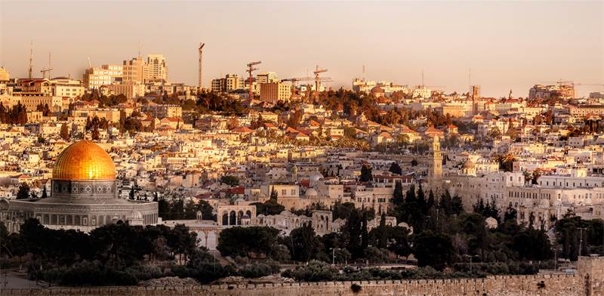**Jerusalem**, the capital of Israel. Jerusalem is the biggest city in Israel, with almost 1,000,000 people living in it!  
Jerusalem is also an opportunity to see a lot of major places in Israel. For your first mission, you will receive pictures and names of places. You will need to match the correct name of the place with its picture. Good luck!

**Jerusalem**, the capital of Israel. Jerusalem is the biggest city in Israel, with almost 1,000,000 people living in it!  
Jerusalem is also an opportunity to see a lot of major places in Israel. For your first mission, you will receive pictures and names of places. You will need to match the correct name of the place with its picture. Good luck!

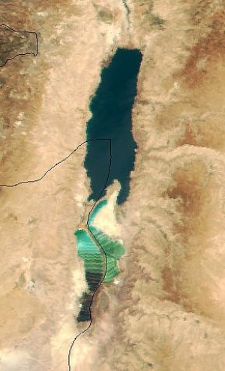**The Dead Sea** is in the Valley area in Israel and is also the lowest place on earth! In 2011, the dead sea was almost chosen to be one of the 7 world wonders!  
In order to get your point in this part of the race, you will need to play Limbo. The team of the last person standing, will win! Good luck!

**The Dead Sea** is in the Valley area in Israel and is also the lowest place on earth! In 2011, the dead sea was almost chosen to be one of the 7 world wonders!  
In order to get your point in this part of the race, you will need to play Limbo. The team of the last person standing, will win! Good luck!

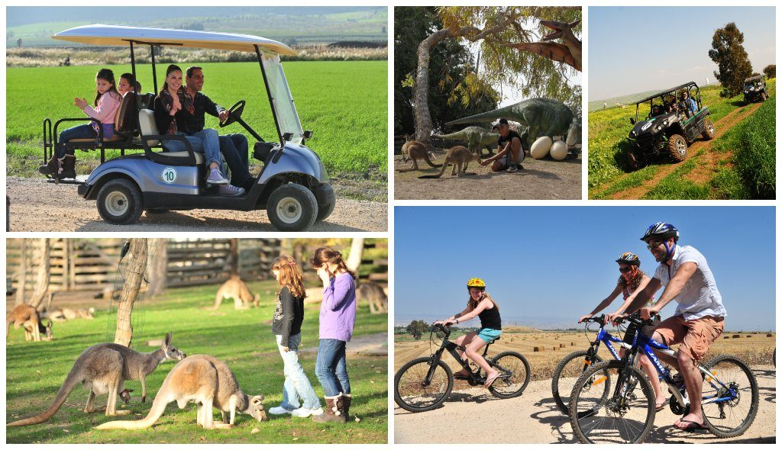In one of the northeast parts of the Valley, is a special Zoo called the Gangooroo. It's a combination of the word garden in Hebrew, and kangaroo. We will hand you the next envelope right now, BUT, you cannot open it until you finish the race! What race are we talking about? You're going to find out! Good luck!

In one of the northeast parts of the Valley, is a special Zoo called the Gangooroo. It's a combination of the word garden in Hebrew, and kangaroo. We will hand you the next envelope right now, BUT, you cannot open it until you finish the race! What race are we talking about? You're going to find out! Good luck!

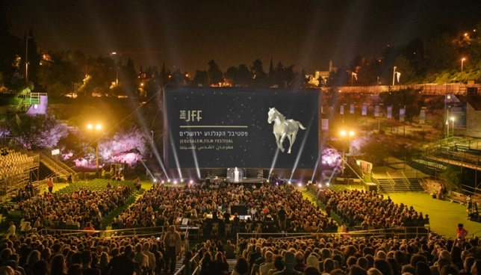Every year in Jerusalem there's the Israeli Film Fest. You will watch a short video on Jerusalem. Pay attention! It will help you later in the race!

Every year in Jerusalem there's the Israeli Film Fest. You will watch a short video on Jerusalem. Pay attention! It will help you later in the race!

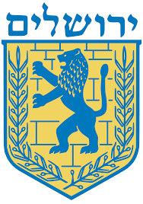The symbol of Jerusalem is a roaring lion, with the background of the western wall and olive branches. The team who will recreate the symbols with only their bodies will win! Good luck!

The symbol of Jerusalem is a roaring lion, with the background of the western wall and olive branches. The team who will recreate the symbols with only their bodies will win! Good luck!