**Coastal Area and the Plain Area**

**Ages:** Between 8-12 grade.

**Time:** About an hour.

**Opening:** Remembering what we did last time we met. Opening the map of Israel and explaining where we are going to visit today. (4 min).

**Body:**

* **First envelope** – "Tel Aviv, the big city, the city that never sleeps. One of the things Tel Aviv is known for is its incredible night life! The night clubs in Tel Aviv are packed and full of people dancing and having a good time. You're going to play musical chairs with Israeli popular music! The group of the last person standing will win the point! Good luck!" (12 min).
* **Second envelope** – "Caesarea, a big city on the coast of Israel. In the days when the Roman Empire ruled that area, Caesarea was a big deal. They built a huge amphitheater which is used up till this day in Israel! You must select 2 members of your group who will perform in front of us a situation which we will present them. But beware! We might decide to change the genre of the show!" (10 min).  
  Situations: Father tells son his not his father, a friend ruins a surprise party to their friend, a job interview.  
  Genres: Drama, Thriller, Musical, Comedy, Telenovela, Tragedy, Broadway show, Miming.
* **Third envelope** – "The coastline of Israel is super long (in Israel scale), some people hike it all at once! You will need to play the Israeli game '3 sticks' to win the point for this mission! Good luck!" (5 min).
* **Fourth envelope** – "In the city **Jaffa**, there is a famous clock tower which every Israeli knows about. You will need to play the Israeli game "Clock" and try to win! The group of the winner will receive a point! Good luck!" (12 min).
* **Fifth envelope** – "**Acre** is a big port city in Israel. The city is mostly known for its fish market. So just like fish, who do not talk, a volunteer will need to act out in miming to your group words. The first group who will guess all the words correctly will win! Good luck!" (7 min).  
  Words: Tel Aviv, Dance, Night Club, Caesarea, Amphitheater, Miming, Movie, Broadway, Tragedy, Sea, Land, Game, Israel, Coast, Watch, Clock, Tower, Fish, Silence, Word, Winning, Finish Matt.

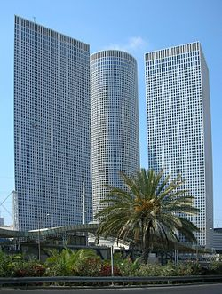 Tel Aviv, the big city, the city that never sleeps. One of the things Tel Aviv is known for is its incredible night life! The night clubs in Tel Aviv are packed and full of people dancing and having a good time. You're going to play musical chairs with Israeli popular music! The group of the last person standing will win the point! Good luck!

 Tel Aviv, the big city, the city that never sleeps. One of the things Tel Aviv is known for is its incredible night life! The night clubs in Tel Aviv are packed and full of people dancing and having a good time. You're going to play musical chairs with Israeli popular music! The group of the last person standing will win the point! Good luck!

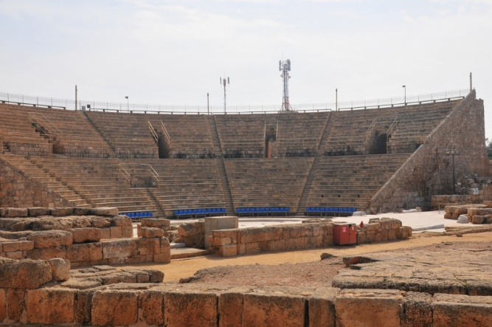Caesarea, a big city on the coast of Israel. In the days when the Roman Empire ruled that area, Caesarea was a big deal. They built a huge amphitheater which is used up till this day in Israel! You must select 2 members of your group who will perform in front of us a situation which we will present them. But beware! We might decide to change the genre of the show!

Caesarea, a big city on the coast of Israel. In the days when the Roman Empire ruled that area, Caesarea was a big deal. They built a huge amphitheater which is used up till this day in Israel! You must select 2 members of your group who will perform in front of us a situation which we will present them. But beware! We might decide to change the genre of the show!

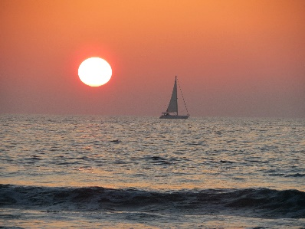 The coastline of Israel is super long (in Israel scale), some people hike it all at once! You will need to play the Israeli game '3 sticks' to win the point for this mission! Good luck!

 The coastline of Israel is super long (in Israel scale), some people hike it all at once! You will need to play the Israeli game '3 sticks' to win the point for this mission! Good luck!

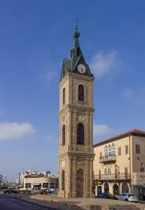In the city **Jaffa**, there is a famous clock tower which every Israeli knows about. You will need to play the Israeli game "Clock" and try to win! The group of the winner will receive a point! Good luck!

In the city **Jaffa**, there is a famous clock tower which every Israeli knows about. You will need to play the Israeli game "Clock" and try to win! The group of the winner will receive a point! Good luck!

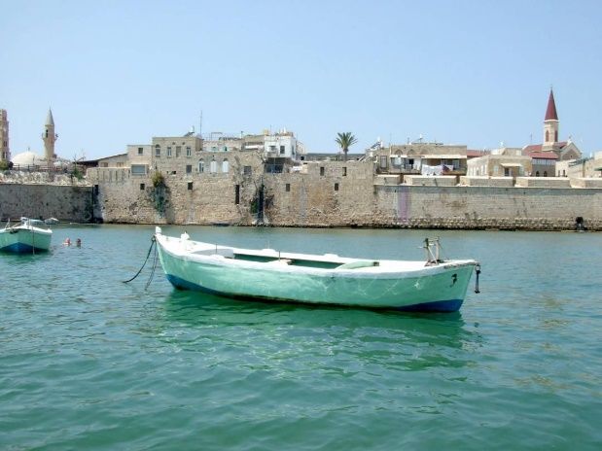**Acre** is a big port city in Israel. The city is mostly known for its fish market. So just like fish, who do not talk, a volunteer will need to act out in miming to your group words. The first group who will guess all the words correctly will win! Good luck!

**Acre** is a big port city in Israel. The city is mostly known for its fish market. So just like fish, who do not talk, a volunteer will need to act out in miming to your group words. The first group who will guess all the words correctly will win! Good luck!