**The Galilei, The Valleys, and Mount Carmel**

**Ages:** Ranges between 8-12 grade.

**Time:** About an hour.

**Opening:** Short explaining what we did last week (1 min).

King of movements (10 min).

**Body:**

* Reminding the groups and the score so far. (2 min).
* **First envelope** – "In Haifa, the biggest city on mount Carmel, there's a magnificent zoo, which every person in Israel knows about: **The Hai Bar**. In its honor, the teams will need to compete each other in the known Israeli game: Hanachash Ba (The snake is coming). You will all need to participate in the game. The team of the last person standing is the winner! Good luck!" (10 min).
* **Second envelope** – "Mount Carmel is considered the 'ever green Mountain'. Why is that? Its trees and vegetation are green and survives all the seasons in Israel! Even the hottest summers (over 110 degrees!). Each group will a stack of cards, and you will need to play Charades! The group who will finish first all of the cards will win! Good luck!" (10 min).
* **Third envelope** – "The Galilei is known for its sheep herds as a main job. You will need to play the game **Sheep Meee**, and the group of the last person standing will win! Good luck!". (10 min).
* **Fourth envelope** – " The Israeli agricultural culture is very dominant and strong. The two most known trees we grow in masses are Date and Olive trees! The Galilei is filled with fields of them! You will need to determine which of the following statements are true and which are false, the team with more correct answers will win! Better hurry, the clock already started…" (5 minutes).
* **Fifth envelope** – "You made it to the finish line! But wait! There's a minefield between you and the finish matt (don't ask us how it got there). You'll need to find your way to the end in order to finish! Good luck!" (20 min).

|  |  |  |  |  |
| --- | --- | --- | --- | --- |
|  |  | **FINISH** | **26** |  |
|  | **23** | **24** | **25** |  |
|  |  | **22** |  |  |
|  |  |  | **21** | **20** |
|  |  |  |  | **19** |
|  |  | **16** | **17** | **18** |
|  |  | **15** |  |  |
|  |  | **14** | **13** |  |
| **8** | **9** | **10** | **11** | **12** |
| **7** | **6** | **5** |  |  |
|  |  | **4** | **3** |  |
|  |  |  | **2** |  |
|  |  |  | **START** | **1** |

**Olive Tree**

The olive's fruit, also called the olive, is of major agricultural importance in the Mediterranean region as the source of olive oil. _______

In the Bible, Olive oil was used only for food and cooking, and not for lighting and sacrificial offerings as some may think _______

In Israel, the most common street name is "**Olive Street**". _______

The oldest olive tree documented is about 1200 years old! _______

**Date Tree**

The Date tree can reach to 70-75 feet! _______

There are male and female Date trees, only the female ones can grow dates! ______

The year after a date is planted, it will start providing fruit _______

Fossil records show that the date palm has existed for at least 100 million years. _______

**Olive Tree**

The olive's fruit, also called the olive, is of major agricultural importance in the Mediterranean region as the source of olive oil. (True).

In Israel, the most common street name is "**Olive Street**". (True).

In the Bible, Olive oil was used only for food and cooking, and not for lighting and sacrificial offerings as some may think (False).

The oldest olive tree documented is about 1200 years old! (False).

**Date Tree**

The Date tree can reach to 70-75 feet! (True).

There are male and female Date trees, only the female ones can grow dates! (True).

The year after a date is planted, it will start providing fruit (False).

Fossil records show that the date palm has existed for at least 100 million years. (False).

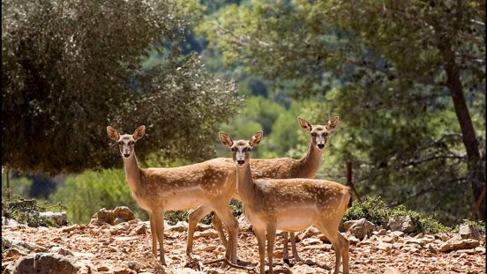In Haifa, the biggest city on mount Carmel, there's a magnificent zoo, which every person in Israel knows about: **The Hai Bar**. In its honor, the teams will need to compete each other in the known Israeli game: Hanachash Ba (The snake is coming). You will all need to participate in the game. The team of the last person standing is the winner! Good luck!

In Haifa, the biggest city on mount Carmel, there's a magnificent zoo, which every person in Israel knows about: **The Hai Bar**. In its honor, the teams will need to compete each other in the known Israeli game: Hanachash Ba (The snake is coming). You will all need to participate in the game. The team of the last person standing is the winner! Good luck!

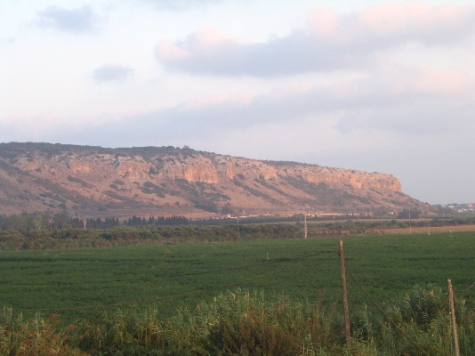 Mount Carmel is considered the 'ever green Mountain'. Why is that? Its trees and vegetation are green and survives all the seasons in Israel! Even the hottest summers (over 110 degrees!). Each group will a stack of cards, and you will need to play Charades! The group who will finish first all of the cards will win! Good luck!

 Mount Carmel is considered the 'ever green Mountain'. Why is that? Its trees and vegetation are green and survives all the seasons in Israel! Even the hottest summers (over 110 degrees!). Each group will a stack of cards, and you will need to play Charades! The group who will finish first all of the cards will win! Good luck!

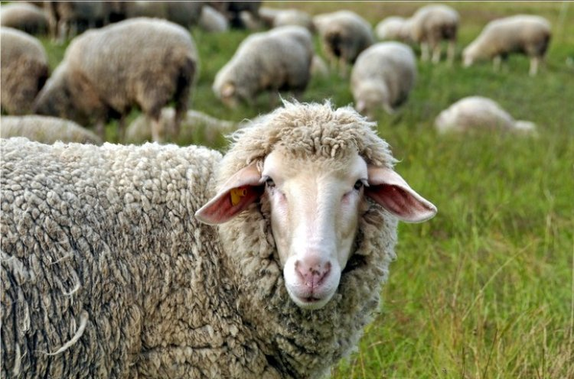The Galilei is known for its sheep herds as a main job. You will need to play the game **Sheep Meh**, and the group of the last person standing will win! Good luck!

The Galilei is known for its sheep herds as a main job. You will need to play the game **Sheep Meh**, and the group of the last person standing will win! Good luck!

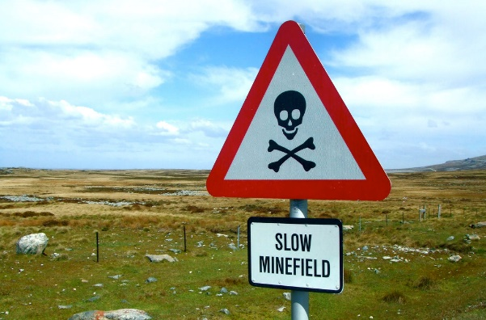You made it to the finish line! But wait! There's a minefield between you and the finish matt (don't ask us how it got there). You'll need to find your way to the end in order to finish! Good luck!

You made it to the finish line! But wait! There's a minefield between you and the finish matt (don't ask us how it got there). You'll need to find your way to the end in order to finish! Good luck!

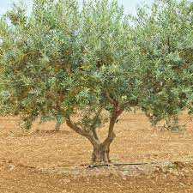The Israeli agricultural culture is very dominant and strong. The two most known trees we grow in masses are Date and Olive trees! The Galilei is filled with fields of them! You will need to determine which of the following statements are true and which are false, the team with more correct answers will win! Better hurry, the clock already started…

The Israeli agricultural culture is very dominant and strong. The two most known trees we grow in masses are Date and Olive trees! The Galilei is filled with fields of them! You will need to determine which of the following statements are true and which are false, the team with more correct answers will win! Better hurry, the clock already started…