**The Golan Hights & The Sea of Galilei**

**Ages:** Ranges between 8-12 grade.

**Total Time:** About an hour.

**Opening:** Self introduction, quick round of names with their place that you most like to visit and explaining about the amazing race (5 min).

**Body:**

* The class needs to split up into 2 teams. Each team needs to make up a name for the group and draw a flag. (7 min)
* **First envelope** – "Welcome to The Amazing Race to Israel! As you might know, Mount Hermon is the tallest mountain in Israel! Its height is about 9232 feet! In order to get to the very top, you would need to use a Cable Car. In your first mission as a team, you would need to transport 10 passengers from the top of the mountain to its bottom. You may use **only** what you will find in your bags. The first team to complete the task will win! Good luck!" (5 min).
* **Second envelope** – "For your second mission, you'll learn about a special guy, who died defending a settlement called Tel Hai in 1920. He's name was Joseph Trumpeldor. His famous last words were "It doesn’t matter, it is good to die for our country". One of the things that he was known for is that he only had one arm. You will need to do arm wrestling with your weak arm between the two groups! The group with the most wins will win! Good luck!" (5 min)
* **Third envelope** – "Every year there's a big swimming competition across the Sea of Galilei, unfortunately for you, you forgot your flippers at home. To keep up with everyone, you'll need to move your whole team from shore to shore stepping only on the dry parts! If anyone touches the water, the whole team will need to start over! Beware of other swimmers, they might not want you to win! Good luck!". (10 min).
* **Forth envelope** – "The Golan Hights has a lot of animals and biological variety. In the summer there are a lot of snakes which damage the agricultural industry there. Your job is to get rid of all the snakes! Good Luck!" (7 min).
* **Fifth envelope** – "One of the main things in the Golan Hights is the sheep flocks. You will need to play the game 'Sheep Meee'. The group of the last person standing will win! Good luck!" (5 min).
* **Sixth envelope** – "You finished today's section! Congratulations! Oh wait… Just one tiny problem… The finish matt has been lost in the depths of the Sea of Galilei (up to 150 feet!). in order to finish this part of the race you'll need to find the finish matt somewhere around the temple. Good luck!". (7 min).

**To Sum Up:** Show a map of Israel and ask where they think the area that we've explored today is. Do a round of one thing that they liked about the lesson today and one thing that they liked less. (for further improvement). (10 min).

**Supplies:** 8 envelopes + 8 missions printed, 2 papers and markers, tubes (plastic or paper), 20 small balls, 2 bigger balls, about 12 cartons for the 3rd mission, finish matt, map of Israel.

Welcome to **The Amazing Race to Israel!** As you might know, Mount Hermon is the tallest mountain in Israel! Its height is about 9232 feet! In order to get to the very top, you would need to use a Cable Car. In your first mission as a team, you would need to transport 10 passengers from the top of the mountain to its bottom. You may use **only** what you will find in your bags. The first team to complete the task will win! Good luck!

Welcome to **The Amazing Race to Israel!** As you might know, Mount Hermon is the tallest mountain in Israel! Its height is about 9232 feet! In order to get to the very top, you would need to use a Cable Car. In your first mission as a team, you would need to transport 10 passengers from the top of the mountain to its bottom. You may use **only** what you will find in your bags. The first team to complete the task will win! Good luck!

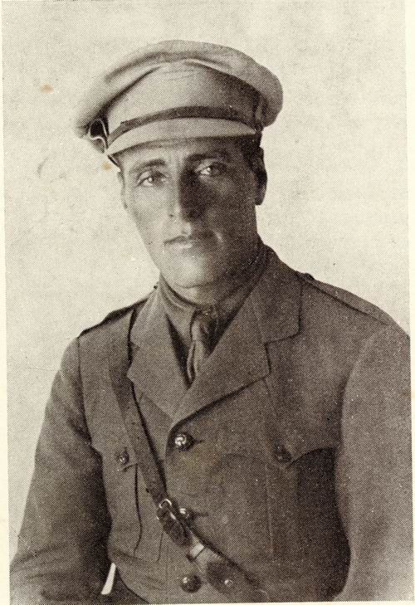 For your second mission, you'll learn about a special guy, who died defending a settlement called Tel Hai in 1920. He's name was Joseph Trumpeldor. His famous last words were "It doesn’t matter, it is good to die for our country". One of the things that he was known for is that he only had one arm. You will need to do arm wrestling with your weak arm between the two groups! The group with the most wins will win! Good luck!

 For your second mission, you'll learn about a special guy, who died defending a settlement called Tel Hai in 1920. He's name was Joseph Trumpeldor. His famous last words were "It doesn’t matter, it is good to die for our country". One of the things that he was known for is that he only had one arm. You will need to do arm wrestling with your weak arm between the two groups! The group with the most wins will win! Good luck!

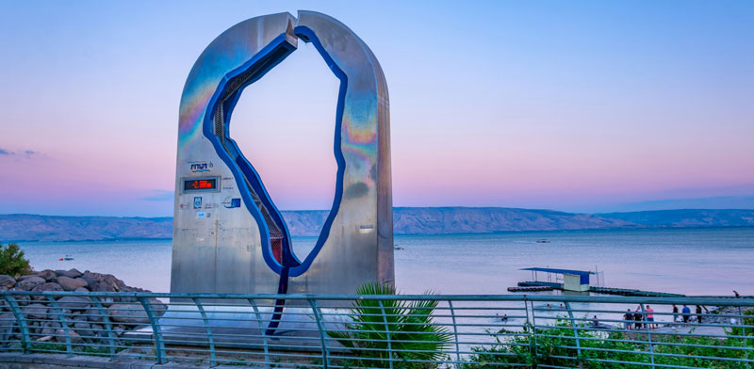Every year there's a big swimming competition across the Sea of Galilei, unfortunately for you, you forgot your flippers at home. To keep up with everyone, you'll need to move your whole team from shore to shore stepping only on the dry parts! If anyone touches the water, the whole team will need to start over! Beware of other swimmers, they might not want you to win! Good luck!

Every year there's a big swimming competition across the Sea of Galilei, unfortunately for you, you forgot your flippers at home. To keep up with everyone, you'll need to move your whole team from shore to shore stepping only on the dry parts! If anyone touches the water, the whole team will need to start over! Beware of other swimmers, they might not want you to win! Good luck!

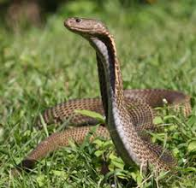The Golan Hights has a lot of animals and biological variety. In the summer there are a lot of snakes which damage the agricultural industry there. Your job is to get rid of all the snakes! Good Luck!

The Golan Hights has a lot of animals and biological variety. In the summer there are a lot of snakes which damage the agricultural industry there. Your job is to get rid of all the snakes! Good Luck!

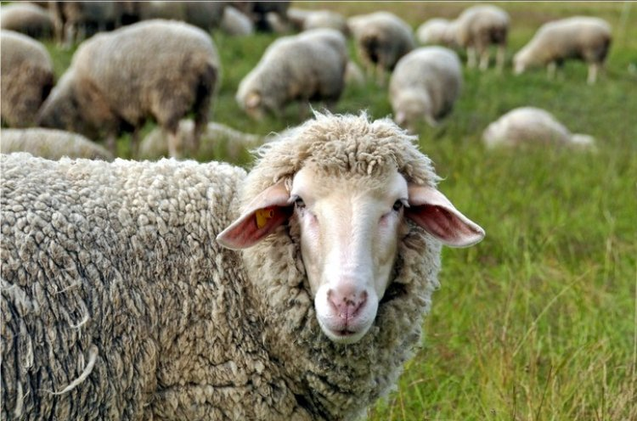One of the main things in the Golan Hights is the sheep flocks. You will need to play the game 'Sheep Meee'. The group of the last person standing will win! Good luck!

One of the main things in the Golan Hights is the sheep flocks. You will need to play the game 'Sheep Meee'. The group of the last person standing will win! Good luck!

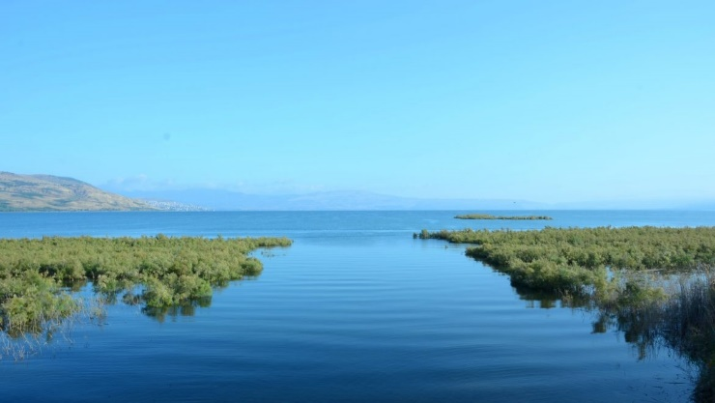You finished today's section! Congratulations! Oh wait… Just one tiny problem… The finish matt has been lost in the depths of the Sea of Galilei (up to 150 feet!). in order to finish this part of the race you'll need to find the finish matt somewhere around the temple. Good luck!

You finished today's section! Congratulations! Oh wait… Just one tiny problem… The finish matt has been lost in the depths of the Sea of Galilei (up to 150 feet!). in order to finish this part of the race you'll need to find the finish matt somewhere around the temple. Good luck!