[](http://www.google.co.il/url?sa=i&rct=j&q=&esrc=s&source=images&cd=&cad=rja&uact=8&docid=MXoLSxhXVhJ1dM&tbnid=szfcNKiHsM52SM:&ved=0CAUQjRw&url=http://keeprecipes.com/recipe/howtocook/indian-shakshuka-%E2%80%94-poached-eggs-curry-sauce&ei=Kup4U4z-JOOH4gTa14HYBw&bvm=bv.66917471,d.bGE&psig=AFQjCNG1p85efesxUR7urIF28I1k4eqKGw&ust=1400519511253217)Ingredients

* 2 tablespoons of oil
* 1 Onion
* 2 garlic cloves
* 2 eggs
* 2 tomatoes
* 1/2 cup (120 mL) of water
* Basic spices (salt, pepper and cumin)
* 1 green pepper
* Hot sauce (optional)

Steps

1. Heat a medium sized pan with two tablespoons of oil in it.
2. Chop an onion into very small pieces and add to the hot pan.
3. Add two cloves of chopped garlic.
4. Add two chopped tomatoes and one chopped green pepper to the onion, once you noticed the onion's turned gold in colour. If you want the shakshuka to be spicy, add a tablespoon of your favorite hot sauce or chili powder. At this point you should also add a sausage or any other ingredient to make your shakshuka a bit more creative and interesting (see tips section).
5. Wait for 5 minutes.
6. Add 1/2 a cup of hot water and some salt, pepper and cumin. While the pan is covered, let the sauce work itself for a while - anywhere between 10 and 20 minutes - depends on how you like your shakshuka.
7. Stir the sauce occasionally.
8. Add two unscrambled eggs on top of the sauce and cover the pan again. As soon as the egg whites turn white, the shakshuka is ready for serving.
9. Serve the shakshuka in the pan, along with white bread.

* Shakshuka can be eaten for breakfast, lunch, or dinner. For breakfast, serve with warm crusty bread or pita that can be dipped into the sauce (if you’re gluten-intolerant or celebrating Passover, skip the bread). For dinner, serve with a green side salad for a light, easy meal

[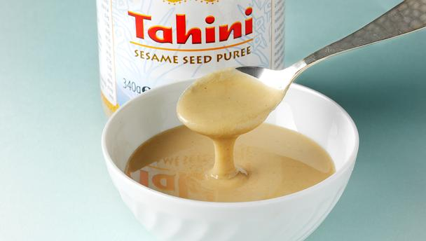](http://www.google.co.il/url?sa=i&rct=j&q=&esrc=s&source=images&cd=&cad=rja&uact=8&docid=B5rp2AwB9OQXpM&tbnid=Dy64DD6xzthGSM:&ved=0CAUQjRw&url=http://www.bbc.co.uk/food/tahini&ei=n-54U9ehN8XOON_2gagM&bvm=bv.66917471,d.bGE&psig=AFQjCNG2ceOVnRTq0dVLzr89J8RoKgcF6A&ust=1400520730200684)Ingredients for 6 people

* 2 cups of sesame tahini
* 1 teaspoon salt
* Half glass of freshly squeezed lemon
* Small spoon of salt
* very Cold water

Preparation

1. put the salt in a bowl, add cold water and stir
2. Add the tahini gradually until you received light tahini
3. Add the lemon and mix well
4. keep the tahini in the fridge until serving

**To upgrade the tahini you can add chopped parsley and garlic.

** You can use it as a dip for bread, Eggplant ,fish and what you see fit

[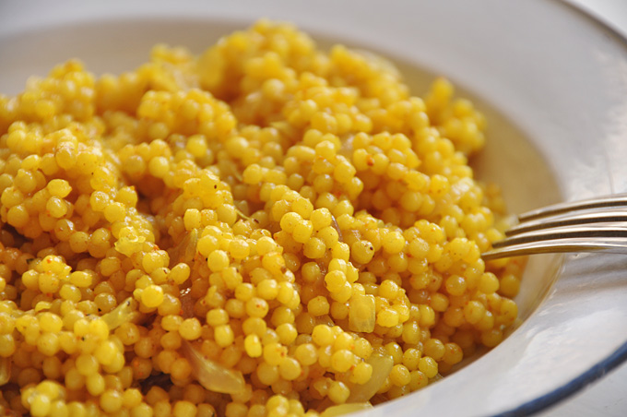](http://www.google.co.il/url?sa=i&rct=j&q=&esrc=s&source=images&cd=&cad=rja&uact=8&docid=sIWWtYfCMBaQ5M&tbnid=QVcoEqc3e1u0KM:&ved=0CAUQjRw&url=http%3A%2F%2Fwww.ptitim.com%2Fcategory%2F%25D7%259B%25D7%259C%25D7%259C%25D7%2599%2F&ei=boqNU_j6J8WjO_LsgKgC&bvm=bv.68191837,d.ZGU&psig=AFQjCNEebLFLXXpByWZE04QpxarRlc32yQ&ust=1401871331312456)Ingredients for 6 people

* 3 cups of Israeli couscous
* 3 cups of water
* A spoon of salt
* A spoon of oil

Preparation

1. Boil the water
2. Add all the ingredients
3. Cook on a low heat for 10 min

**To upgrade you can add tomato sauce, vegetables, cheese, nuts spices and what you see fit.

** "Ptitim" was invented during the [austerity period in Israel](http://en.wikipedia.org/wiki/Austerity_in_Israel) (from 1949 to 1959). Israel's first [Prime Minister](http://en.wikipedia.org/wiki/Prime_minister_of_Israel), [David Ben-Gurion](http://en.wikipedia.org/wiki/David_Ben-Gurion), asked Eugen Proper, one of the founders of the [Osem food company](http://en.wikipedia.org/wiki/Osem_(company)), to quickly devise a wheat-based substitute to rice. Consequently, it was nicknamed "Ben-Gurion's rice" by the people. The company took up the challenge and developed ptitim, which is made of hard [wheat flour](http://en.wikipedia.org/wiki/Wheat_flour) and roasted in an oven. The product was instantly a success, after which ptitim made in the shape of small, dense balls (which the company termed "[couscous](http://en.wikipedia.org/wiki/Couscous)") was added to the original rice-shaped ptitim.

* 4 eggs
* 4 pieces pita bread
* 8 cherry tomatoes, ends trimmed, finely diced
* ½ English cucumber, finely diced
* ½ small white onion, minced
* 1 tablespoon lemon juice from 1 lemon
* 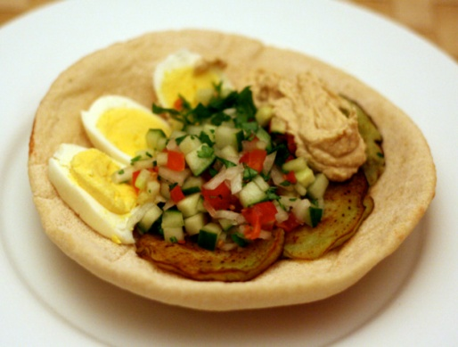1 large eggplant, peeled, halved and sliced ¼-inch thick
* Canola oil
* 1 cup hummus
* ½ cup fresh parsley, chopped
* mango pickle, harisa, or hot sauce of choice
* Procedures

Preparation

1. Pour 1 ½ quarts cool water into medium-sized saucepan. Carefully add eggs. Turn heat to high and bring to a bare simmer, about 180°F. Turn off heat and let sit for ten minutes. Transfer eggs to ice water and let cool. Then peel under cool running water, dry with paper towels, and thinly slice.
2. Meanwhile, preheat oven to 200 degrees. Add pita bread and let warm in oven.
3. Toss together tomatoes, cucumber, onion, and lemon juice in medium-sized bowl. Season with salt to taste.
4. Pour enough oil to coat bottom of 12-inch stainless steel skillet set over medium-high heat. When shimmering, add as many eggplant slices as will fit in one layer. Cook for about four minutes a side, or until they are well browned on each side. They will suck up the oil at first, but after a few minutes, they should purge some of it. Remove slices and drain on paper towel. Add just enough oil to cover bottom of the skillet again. Repeat process until all of the eggplant slices have been cooked.
5. Remove pita from oven. Add a few slices of eggplant, slices of hard-boiled egg, tomato salad, parsley, and hot sauce of choice.

[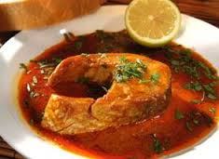](http://www.google.co.il/url?sa=i&source=images&cd=&cad=rja&uact=8&docid=EyXAqrMFq1PK2M&tbnid=ZF_mLzSiz6p4eM&ved=0CAgQjRw&url=http%3A%2F%2Fwww.tapuz.co.il%2Fforums2008%2Fviewmsg.aspx%3Fforumid%3D744%26messageid%3D85307503&ei=2ZGNU8CuBOPB7Abp6oHQDA&psig=AFQjCNFgcvSjD9IDKhOF-dkeriuSVfUYPA&ust=1401873241167203)

Ingredients

* 1-1/2 cups water
* 3 tbl extra virgin olive oil
* juice of 1 lemon
* 2 tablespoons tomato paste
* 1/4 teaspoon salt
* 5 garlic cloves, chopped fine
* 1 teaspoon ground cumin seed
* 1 table spoon sweet paprika
* 1bunch coriander chopped roughly
* 2 to 3 tsp. hot red chili, seeded and chopped
* 2-3 pieces dried sweet red peppers
* 1 kg red snapper, sea bass, halibut, grey mullet or similar firm fleshed fish filets
* lemon wedges

Preparation

1. Heat the oil at low temperature.
2. Add the paprika and cumin seeds and fry until fragrant
3. Mix together ½  cup water, lemon juice, tomato paste, salt, the garlic, and chili and add to the oil. Simmer over low heat for 10 minutes.
4. Add the fish and the remaining water.
5. Add the coriander (reserving some for garnish)
6. Cover the pan and cook over low heat for 15 minutes. Serve warm with lemon wedges and plenty of crusty fresh bread.

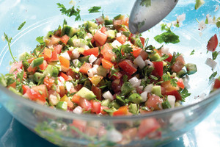

**Ingredients (better of the vegetables are not cold)**

* 1 juicy lemon, halved
* 4 firm ripe tomatoes, diced
* 4 unpeeled cucumbers, diced
* 1 red onion, finely diced
* 1 sweet red pepper, seeded and diced
* 1 carrot finely diced or grated
* 4 lettuce leaves, ripped by hand or chopped
* Salt and freshly ground black pepper to taste
* 3 tablespoons extra virgin olive oil
* 2-3 tablespoons parsley and/or coriander and/or mint leaves, chopped

Preparation

1. Squeeze the juice of half the lemon into a small jar/bowl. Add olive oil and the seasoning. Mix and pour over the vegetables. Serve immediately.